**Task**

1. What is the difference between MongoDB and MYSQL ?

* **MONGODB**
* [MongoDB](https://www.geeksforgeeks.org/mongodb-an-introduction/) is an open-source database developed by MongoDB, Inc.
* MongoDB stores data in JSON-like documents that can vary in structure. It is a popular NoSQL database.
* In MongoDB, each individual records are stored as [‘documents’](https://www.geeksforgeeks.org/mongodb-getting-started/).
* Documents belonging to a particular class or group as stored in a [‘collection’](https://www.geeksforgeeks.org/mongodb-getting-started/).  
  Example: collection of users.
* MongoDB is what is called a [NoSQL database](https://en.wikipedia.org/wiki/NoSQL" \t "https://en.wikipedia.org/wiki/NoSQL). This means that pre-defined structure for the incoming data can be defined and adhered to but also, if required different documents in a collection can have different structures. It has a dynamic schema.
* MongoDB was designed with high availability and scalability in mind, and includes out-of-the-box [replication](https://docs.mongodb.com/manual/replication) and [sharding](https://docs.mongodb.com/manual/sharding" \t "_blank).
* **MYSQL**
* [MySQL](https://www.geeksforgeeks.org/php-mysql-database-introduction/) is a popular open-source relational database management system (RDBMS) that is developed, distributed and supported by Oracle Corporation.
* In MySQL, each individual records are stored as ‘rows’ in a table.
* A ‘table’ is used to store rows (records) of similar type.
* MySQL as the name suggests uses [Structured Query Language (SQL)](https://www.geeksforgeeks.org/structured-query-language/) for database access. The schema can not be changed. The inputs following the given schema are only entered.
* MySQL concept does not allow efficient replication and sharding but in MySQL one can access associated data using joins which minimizes duplication.

1. Create a db and collection of product data, perform the crud operation

**insertOne()**

**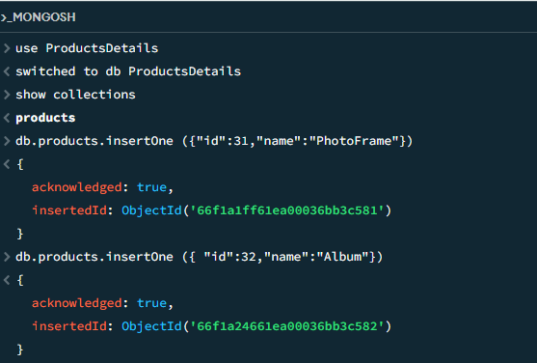**

**insertMany()**

**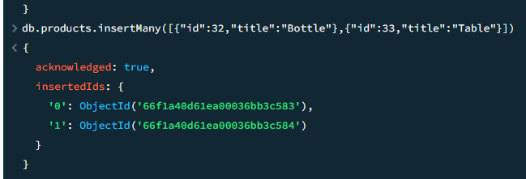**

**Find()**

**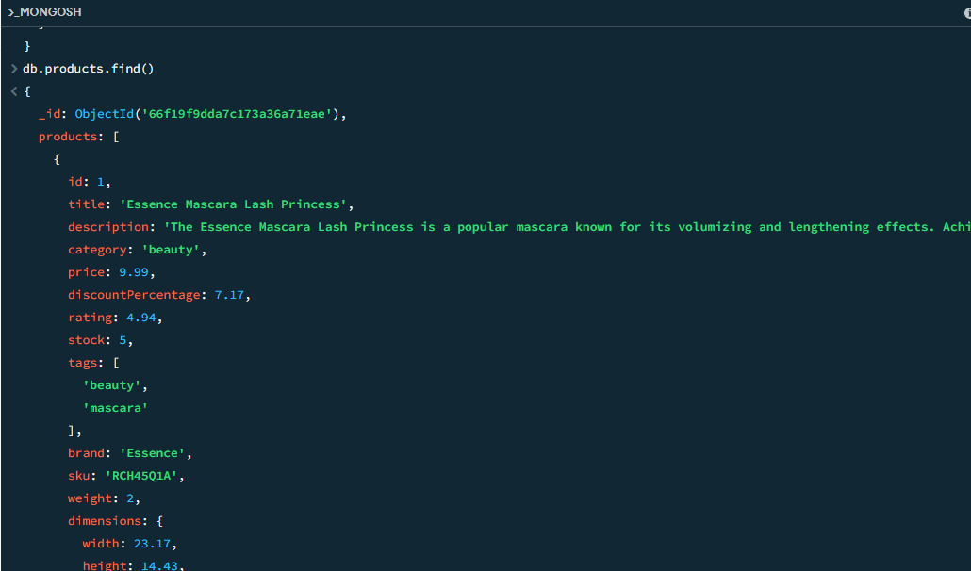**

**updateOne()**

**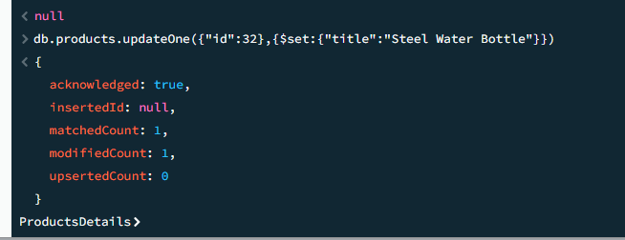**

**updateMany()**

**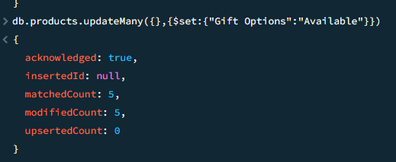**

**deleteOne()**

**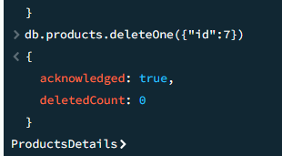**

**deleteMany()**

**